RBAC: Role Based Access Control: governs what an authenticated and authorized user can or cannot do.

Azure Policy: Focuses on deployments (allowed configs, etc)

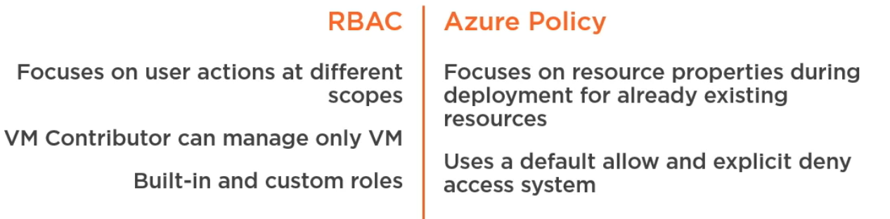

Some default Azure Policies:

* Allowed Locations
* VM SKUs (Stuck Keeping Units): controlling sizes of VMs
* Deploy MMS extensions (extension used to onboard VM into Azure Log Analytics) ~OMS

**Definitions:** Collections of policies

-Mode Incremental/Complete: incremental does not delete any other item in the resource group. Complete deletes everything before running the template

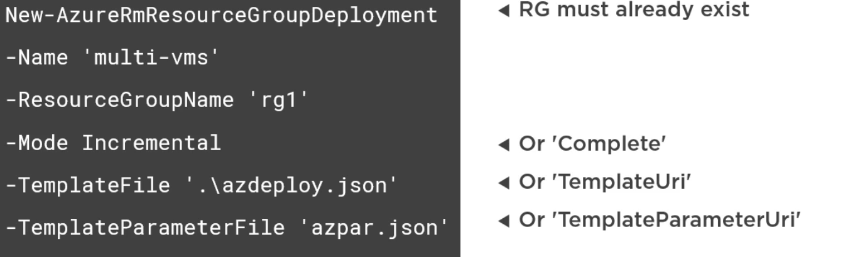

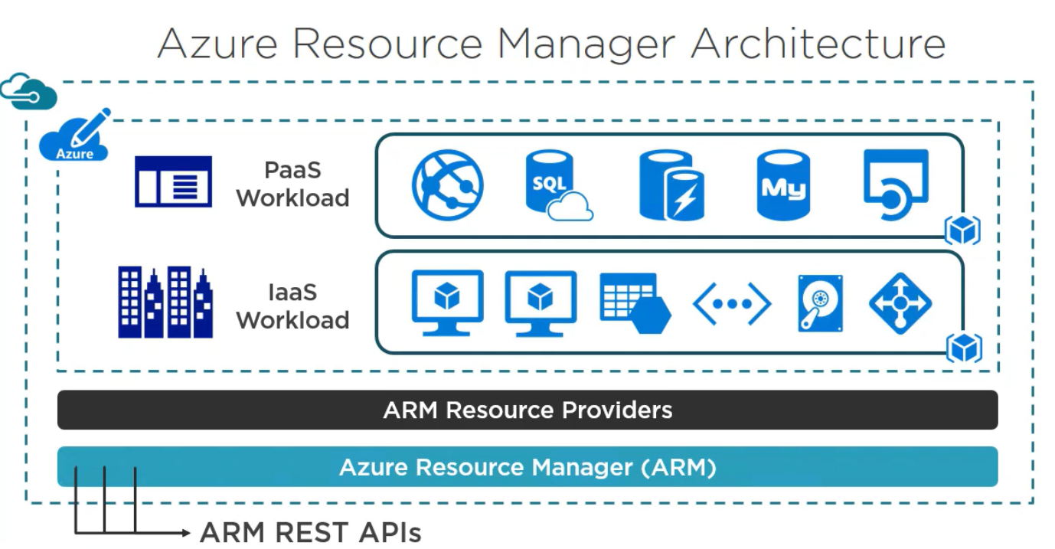

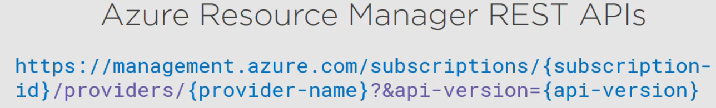

* Resource grouping
* Resource dependencies (define deployment order, etc)
* Repeatable deployments
* Deployment templates
* RBAC (role based access control)
* Granular billing, resource tagging